**Name – Shubh srivastava**

**Roll No. – 21051429**

**Section – CSE 15**

**WT LAB 1**

Design a Student registration form for KIIT central library using HTML text formatting

tags, and including the following components in order:

1) KIIT Central Library in the middle of the form and present on the top

2) A "Student Registration Form" message moving from right to left constantly with its

background image as green

3) Next, group all the below-related information by inserting a legend by the name of

"Student Details":

Under the legend:

a) Ask for the student’s name, with three field names namely: First Name, Middle Name,

and Last Name

Each of the above should be followed by corresponding textboxes for the student

to enter

b) Ask for the student's email with the field name "Email" followed by a textbox

for the student to enter into it

c) Ask for the student's password with the field name "Password" followed by a

textbox for the student to enter into it

d) Next, again ask the student to enter their password for confirmation by using

a field "Confirm your password" followed by a textbox for the student to enter

into it for confirmation

e) Ask for the student to fill in their gender by using the field name "Gender"

followed by providing three radio buttons bearings: Male, Female, and Others

f) Ask the student to fill in their addresses:

i) First ask for the correspondence address using the field "Enter your

Correspondence Address" followed by multi-line

input textbox

ii) Repeat the above, but this time with the field name "Enter your permanent

Address" followed by multi-line

input textbox

g) Ask the student to enter their Domicile State with the field: "Domicile" followed

by choosing from one of the following options:

i) Odisha ii) West Bengal iii) Jharkhand iv) Bihar V) Uttar Pradesh vi)

Andhra Pradesh vii) Telangana

h) Finally, ask the student to submit the details by designing a submit button

with the value "Sign up"

Now, I) Field names need to be formatted using appropriate Text Formatting Tags

II) The legend names should be in bold font

III) Use appropriate Headers depending upon what stage you are applying it

**CODE:**

<!DOCTYPE html>

<html lang="en">

<head>

    <meta charset="UTF-8">

    <meta http-equiv="X-UA-Compatible" content="IE=edge">

    <meta name="viewport" content="width=device-width, initial-scale=1.0">

    <title>Central Library</title>

</head>

<style>

    .box1{

        background-color: green;

        border: 3px solid black;

        border-radius: 9px;

        color: white;

        font-size: 27px;

        padding: 3px;

    }

</style>

<body>

    <header>

    <h1 align="center" style="font-family:'Lucida Sans', 'Lucida Sans Regular', 'Lucida Grande', 'Lucida Sans Unicode', Geneva, Verdana, sans-serif;">KIIT Central Library</h1>

    <div class="box1"> <marquee <!--bgcolor=#54B435-->Student Registration Form </marquee> </div>

<br>

</header>

<main>

    <form>

    <fieldset>

        <legend align="center"><b>Student Details</b></legend><br>

        <label for="FName">

            <b>First Name:</b> <input type="text" id="FName">

        </label>&nbsp;&nbsp;&nbsp;&nbsp;&nbsp;&nbsp;&nbsp;&nbsp;

        <label for="MName">

           <b> Middle Name:</b> <input type="text" id="MName">

        </label>&nbsp;&nbsp;&nbsp;&nbsp;&nbsp;&nbsp;&nbsp;&nbsp;

        <label for="LName">

            <b>Last Name:</b> <input type="text" id="LName">

        </label><br><br>

        <label for="Email">

            <b>Email Address:</b> <input type="email" id="Email">

        </label><br><br>

        <label for="PWD">

            <b>Password: </b><input type="password" id="PWD">

        </label><br><br>

        <label for="PWDConfirm">

            <b>Enter Your Password Again: </b><input type="password" id="PWDConfirm">

        </label><br><br>

        <b>Gender:</b>

        <label for="Gender1">

            <input type="radio" name="Gender" id="Gender1">Male

        </label>

        <label for="Gender2">

            <input type="radio" name="Gender" id="Gender2">Female

        </label>

        <label for="Gender3">

            <input type="radio" name="Gender" id="Gender3">Others

        </label> <br><br>

        <i>Enter Your Correspondence Address:</i><br>

        <label for="Address">

            <textarea name="add" id="Address" cols="30" rows="5" placeholder="Type here..."></textarea>

        </label><br><br>

        <i>Enter Your Permanent Address:</i><br>

        <label for="Address">

            <textarea name="add" id="Address" cols="30" rows="5" placeholder="Type here..."></textarea>

        </label><br><br>

        <label for="State">

            <select name="StateName" id="Sta">

                <option>Select your State</option>

                <option>Odisha</option>

                <option>West Bengal</option>

                <option>Jharkhand</option>

                <option>Bihar</option>

                <option>Uttar Pradesh</option>

                <option>Andhra Pradesh</option>

                <option>Telangana</option>

              </select>

        </label><br><br>

        <label for="submitting">

            <input type="submit" value="Sign Up">

        </label>

    </fieldset>

</main>

</form>

</body>

</html>

**Screenshot:**

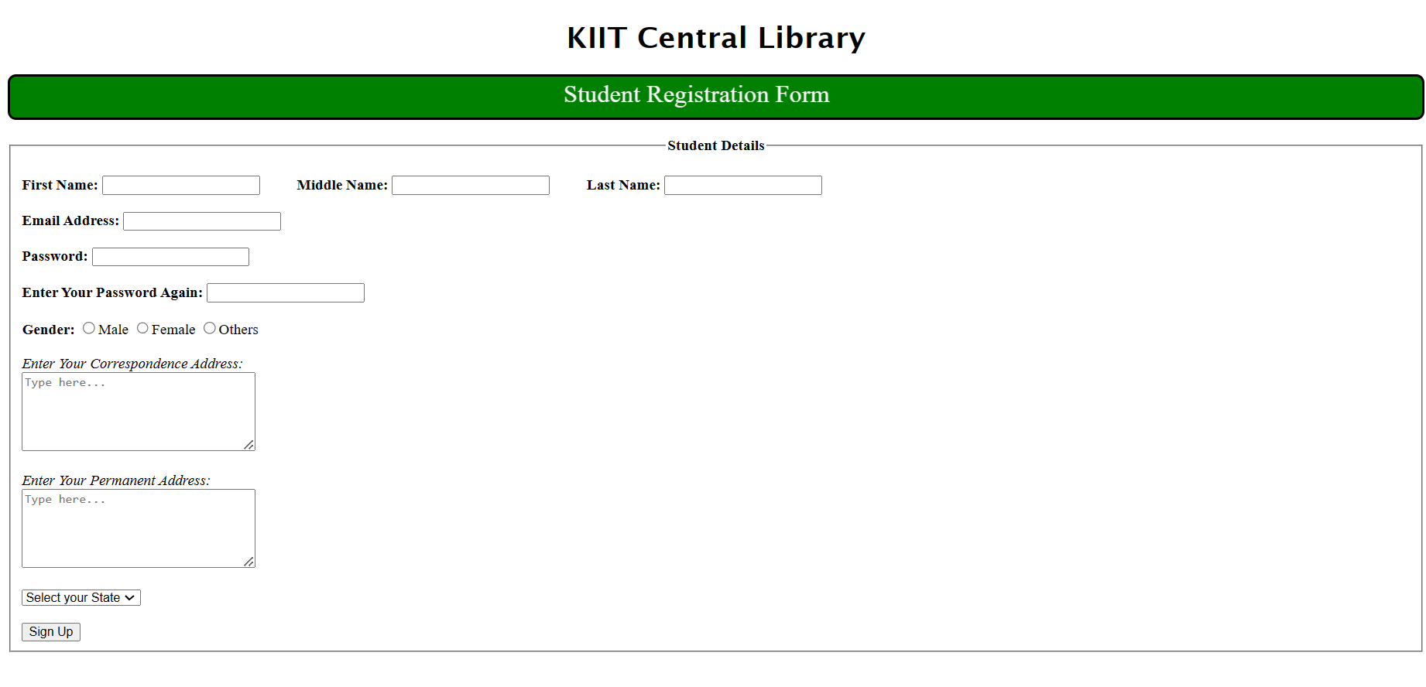

**Name – Shubh srivastava**

**Roll No. – 21051429**

**Section – CSE 15**

**WT LAB 2**

A. Create a web page as follows: having 3 frames. KIIT University will move in the marquee to

the top frame. In the left frame 3 hyperlinks named Login, About KIIT, and Feedback

will be there, and clicking on that the desired result will be displayed in the main frame.

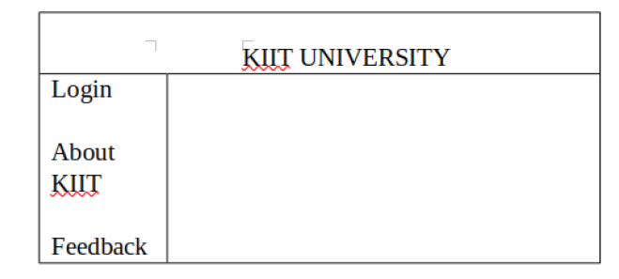

**CODE:**

**File: main.html**

<!DOCTYPE html>

<html lang="en">

<head>

    <meta charset="UTF-8">

    <meta http-equiv="X-UA-Compatible" content="IE=edge">

    <meta name="viewport" content="width=device-width, initial-scale=1.0">

    <title>Question 1</title>

</head>

<frameset  rows="15%,80%"  >

    <frame src="Question1.html" name="top">

        <frameset cols="50%,50%">

            <frame src="left.html" name="left">

            <frame src="right.html" name="right">

         </frameset>

</frameset>

</html>

**File: Question 1.html**

<!DOCTYPE html>

<html lang="en">

<head>

    <meta charset="UTF-8">

    <meta http-equiv="X-UA-Compatible" content="IE=edge">

    <meta name="viewport" content="width=device-width, initial-scale=1.0">

    <title>Document</title>

</head>

<style>

    @font-face {

  font-family: Custom;

  src: url(Azonix.otf);

}

h1{

    font-family: Custom;

}

body{

    background: linear-gradient(to top left, #9900cc, #0066ff);

}

</style>

    <body>

    <h1 align="center" style="font-size: 40px; color: white;">KIIT University</h1>

</body>

</html>

**File: Left.html**

<!DOCTYPE html>

<html lang="en">

  <head>

    <meta charset="UTF-8" />

    <meta http-equiv="X-UA-Compatible" content="IE=edge" />

    <meta name="viewport" content="width=device-width, initial-scale=1.0" />

    <title>Left</title>

  </head>

  <style>

    @font-face {

      font-family: Custom;

      src: url(Azonix.otf);

    }

    a {

      color: #0066ff;

      font-size: 30px;

      font-family: Custom;

      color: linear-gradient(to top left, #9900cc 0%, #0066ff 100%);

    }

#Log:hover{

    color: #9900cc;

}

#abo:hover{

    color: #9900cc;

}

#feedme:hover{

    color: #9900cc;

}

  </style>

  <body>

    <a href="Login.html" target="right" id="Log">Login</a><br /><br /><br />

    <a href="abt.html" target="right" id="abo">About KIIT</a><br /><br /><br />

    <a href="Feedback.html" target="right" id="feedme">Feedback</a><br /><br /><br />

  </body>

</html>

**File: right.html**

<!DOCTYPE html>

<html lang="en">

<head>

    <meta charset="UTF-8">

    <meta http-equiv="X-UA-Compatible" content="IE=edge">

    <meta name="viewport" content="width=device-width, initial-scale=1.0">

    <title>Document</title>

</head>

<body>

</body>

</html>

**File: Login.html**

<!DOCTYPE html>

<html lang="en">

<head>

    <meta charset="UTF-8">

    <meta http-equiv="X-UA-Compatible" content="IE=edge">

    <meta name="viewport" content="width=device-width, initial-scale=1.0">

    <title>Central Library</title>

</head>

<style>

    .box1{

        background-color: green;

        border: 3px solid black;

        border-radius: 9px;

        color: white;

        font-size: 27px;

        padding: 3px;

    }

</style>

<body>

    <header>

        <h1 align="center" style="font-family:'Lucida Sans', 'Lucida Sans Regular', 'Lucida Grande', 'Lucida Sans Unicode', Geneva, Verdana, sans-serif;">KIIT Central Library</h1>

        <div class="box1"> <marquee <!--bgcolor=#54B435-->Student Registration Form </marquee> </div>

    <br>

    </header>

    <main>

        <form>

        <fieldset>

            <legend align="center"><b>Student Details</b></legend><br>

            <label for="FName">

                <b>First Name:</b> <input type="text" id="FName">

            </label>&nbsp;&nbsp;&nbsp;&nbsp;&nbsp;&nbsp;&nbsp;&nbsp;

            <label for="MName">

               <b> Middle Name:</b> <input type="text" id="MName">

            </label>&nbsp;&nbsp;&nbsp;&nbsp;&nbsp;&nbsp;&nbsp;&nbsp;

            <label for="LName">

                <b>Last Name:</b> <input type="text" id="LName">

            </label><br><br>

            <label for="Email">

                <b>Email Address:</b> <input type="email" id="Email">

            </label><br><br>

            <label for="PWD">

                <b>Password: </b><input type="password" id="PWD">

            </label><br><br>

            <label for="PWDConfirm">

                <b>Enter Your Password Again: </b><input type="password" id="PWDConfirm">

            </label><br><br>

            <b>Gender:</b>

            <label for="Gender1">

                <input type="radio" name="Gender" id="Gender1">Male

            </label>

            <label for="Gender2">

                <input type="radio" name="Gender" id="Gender2">Female

            </label>

            <label for="Gender3">

                <input type="radio" name="Gender" id="Gender3">Others

            </label> <br><br>

            <i>Enter Your Correspondence Address:</i><br>

            <label for="Address">

                <textarea name="add" id="Address" cols="30" rows="5" placeholder="Type here..."></textarea>

            </label><br><br>

            <i>Enter Your Permanent Address:</i><br>

            <label for="Address">

                <textarea name="add" id="Address" cols="30" rows="5" placeholder="Type here..."></textarea>

            </label><br><br>

            <label for="State">

                <select name="StateName" id="Sta">

                    <option>Select your State</option>

                    <option>Odisha</option>

                    <option>West Bengal</option>

                    <option>Jharkhand</option>

                    <option>Bihar</option>

                    <option>Uttar Pradesh</option>

                    <option>Andhra Pradesh</option>

                    <option>Telangana</option>

                  </select>

            </label><br><br>

            <label for="submitting">

                <input type="submit" value="Sign Up">

            </label>

        </fieldset>

    </main>

</form>

</body>

</html>

**File: abt.html**

<!DOCTYPE html>

<html lang="en">

<head>

    <meta charset="UTF-8">

    <meta http-equiv="X-UA-Compatible" content="IE=edge">

    <meta name="viewport" content="width=device-width, initial-scale=1.0">

    <title>About</title>

</head>

<body style="font-style: italic">

    Kalinga Institute of Industrial Technology, formerly KIIT University, is a private deemed university located in Bhubaneswar, Odisha, India. It primarily emphasizes on higher education and research in engineering and science

</body>

</html>

**File: Feedback.html**

<!DOCTYPE html>

<html lang="en">

<head>

    <meta charset="UTF-8">

    <meta http-equiv="X-UA-Compatible" content="IE=edge">

    <meta name="viewport" content="width=device-width, initial-scale=1.0">

    <title>Document</title>

</head>

<body>

    <div class="feed" align="left">

        <h3>How do you like our service?</h3>

        <textarea name="Feed" id="feedback" cols="30" rows="10" placeholder="Type here..."></textarea>

    </div>

</body>

</html>

**Screenshots:**

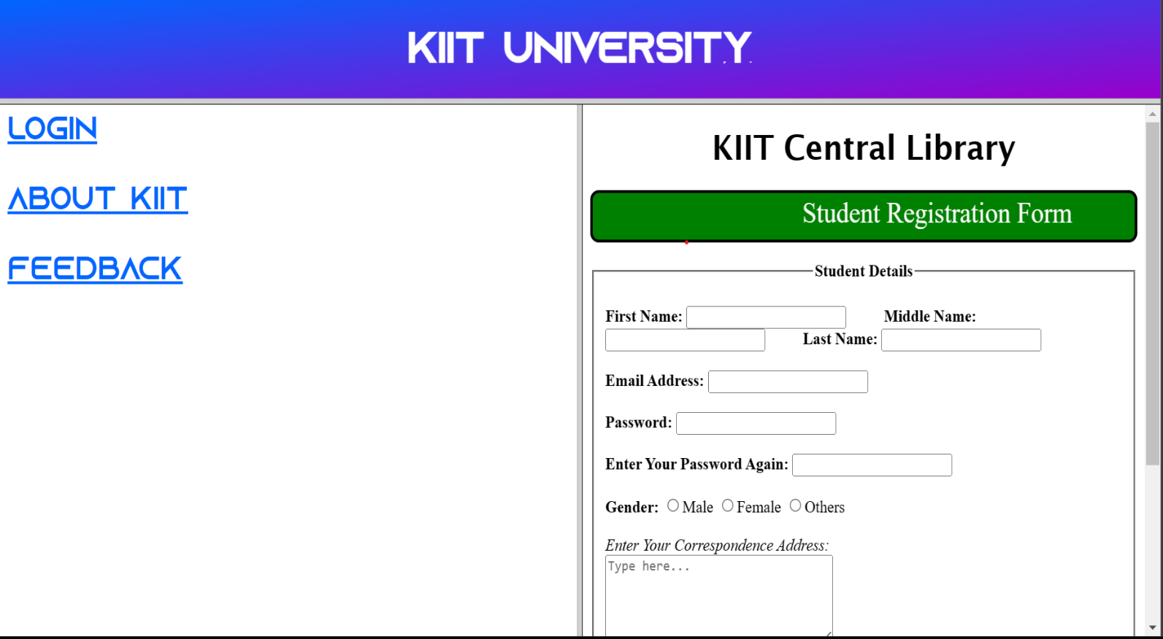

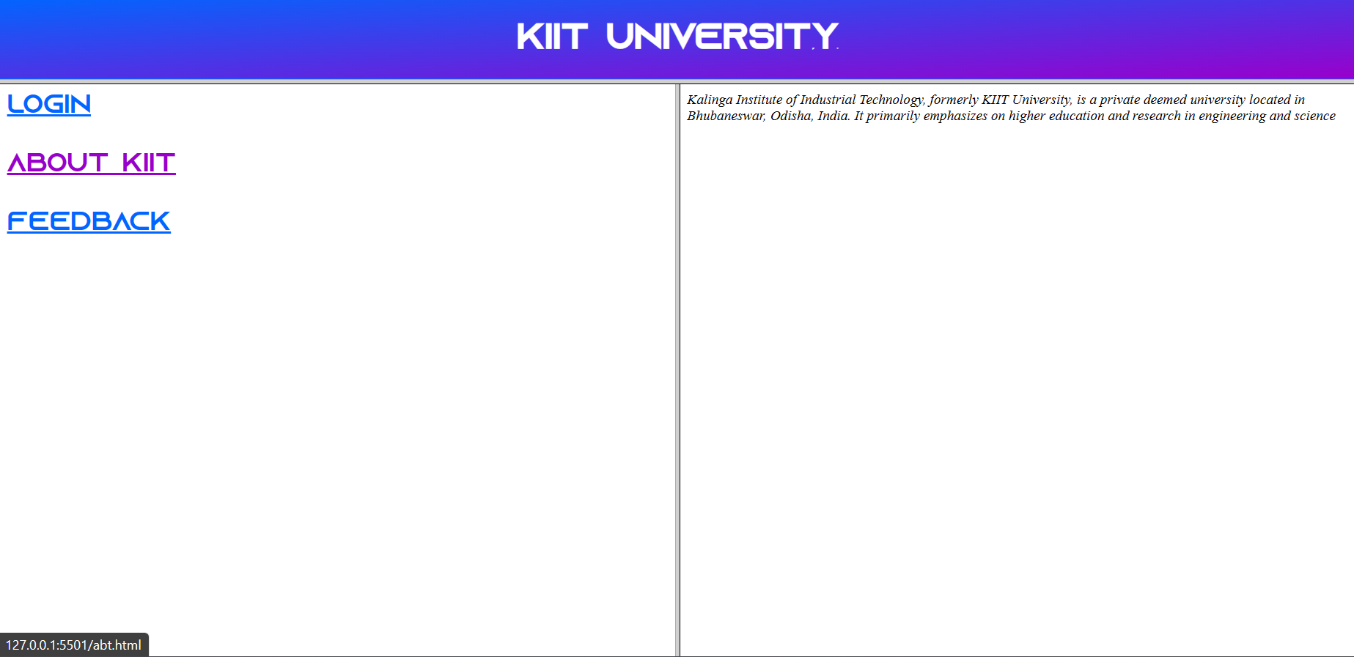

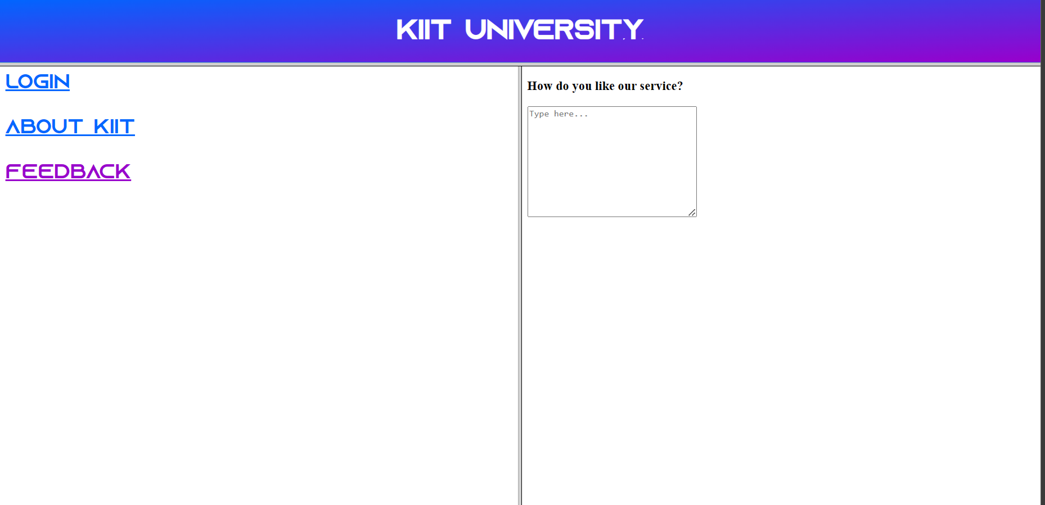

B. Create a web page using Ordered, Unordered, Directory, and Nested List which will

display the output as follows:

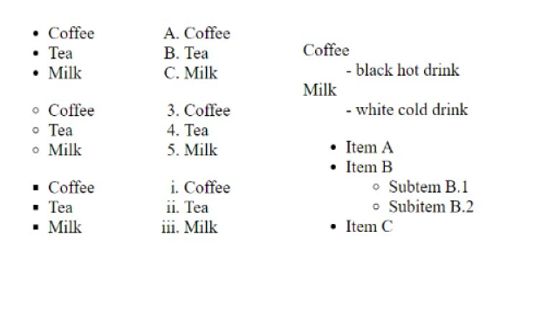

**Code:**

<!DOCTYPE html>

<html lang="en">

<head>

    <meta charset="UTF-8">

    <meta http-equiv="X-UA-Compatible" content="IE=edge">

    <meta name="viewport" content="width=device-width, initial-scale=1.0">

    <title>Question 2</title>

</head>

<style>

*{

    font-size: 20px;

    line-height: 40px;

}

.A {

      display: inline-block;

      /* visibility: hidden; */

      width: 30%;

      height: 350px;

      margin: 7px;

      padding: 10px;

      border-radius: 12px;

      line-height: 30px;

      font-style: italic;

    }

    .B {

        display: inline-block;

      width: 30%;

      height: 350px;

      margin: 7px;

      padding: 10px;

      border-radius: 12px;

        /* box-sizing: border-box; */

      line-height: 30px;

      visibility: visible;

      font-style: oblique 40deg;

    }

    .C {

        display: inline-block;

      width: 30%;

      height: 350px;

      margin: 7px;

      padding: 10px;

      border-radius: 12px;

      line-height: 30px;

      visibility: visible;

      font-style: oblique 40deg;

    }

</style>

<body>

    <div class="container">

        <div class="A">

            <ul>

                <li>Coffee</li>

                <li>Tea</li>

                <li>Milk</li>

            </ul>

            <ul type="circle">

                <li>Coffee</li>

                <li>Tea</li>

                <li>Milk</li>

            </ul>

            <ul type="square">

                <li>Coffee</li>

                <li>Tea</li>

                <li>Milk</li>

            </ul>

        </div>

        <div class="B">

            <ol type="A">

            <li>Coffee</li>

            <li>Tea</li>

            <li>Milk</li>

        </ol>

        <ol type="1">

            <li>Coffee</li>

            <li>Tea</li>

            <li>Milk</li>

        </ol>

        <ol type="i">

            <li>Coffee</li>

            <li>Tea</li>

            <li>Milk</li>

        </ol></div>

    <div class="C">

        <dl>

            <dt>Coffee</dt>

            <dd>-black hot drink</dd>

            <dt>Milk</dt>

            <dd>-white cold drink</dd>

        </dl>

        <dl>

            <dt>

                <ul>

                    <li>Item A</li>

                    <li>Item B</li>

                </ul>

            </dt>

            <dd>

                <ul type="circle">

                    <li>Subitem B.1</li>

                    <li>Subitem B.2</li>

                </ul>

            </dd>

            <dt>

                <ul>

                    <li>Item C</li>

                </ul>

            </dt>

        </dl>

    </div>

    </div>

</body>

</html>

**Screenshot:**

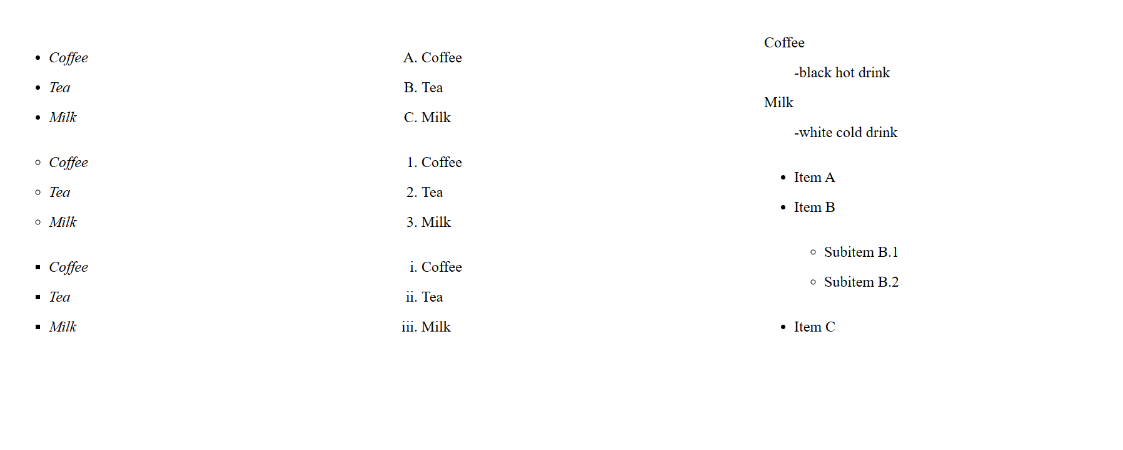

C. Design a web page using inline style applied on <h1> tag using style attribute which will

display the following output:

D. Design the same web page as shown in (C) using an internal style sheet.

E. Design the same web page as shown in (C) using an external style sheet.



**C.**

<!DOCTYPE html>

<html lang="en">

<head>

    <meta charset="UTF-8">

    <meta http-equiv="X-UA-Compatible" content="IE=edge">

    <meta name="viewport" content="width=device-width, initial-scale=1.0">

    <title>Question 3</title>

</head>

<body>

    <h1 align="center" style="font-size: 50px;color: red; text-decoration: underline;">KIIT University</h1>

</body>

</html>

**D.**

<!DOCTYPE html>

<html lang="en">

<head>

    <meta charset="UTF-8">

    <meta http-equiv="X-UA-Compatible" content="IE=edge">

    <meta name="viewport" content="width=device-width, initial-scale=1.0">

    <title>Question 3</title>

</head>

<style>

    h1{

        font-size: 50px;

        color: red;

        text-decoration: underline;

    }

</style>

<body>

    <h1 align="center" >KIIT University</h1>

</body>

</html>

**E.**

<!DOCTYPE html>

<html lang="en">

<head>

    <meta http-equiv="X-UA-Compatible" content="IE=edge">

    <meta name="viewport" content="width=device-width, initial-scale=1.0">

    <title>Question 3</title>

    <link rel="stylesheet" href="style.css">

</head>

<body>

    <h1 align="center" >KIIT University</h1>

</body>

</html>

**File: Style.css**

h1{

    font-size: 50px;

    color: red;

    text-decoration: underline;

}

**Screenshot:**

